Long Jump

Git Link: https://github.com/bristollmatthew/Mobile-Game-Development

Concept & Core Gameplay Loop

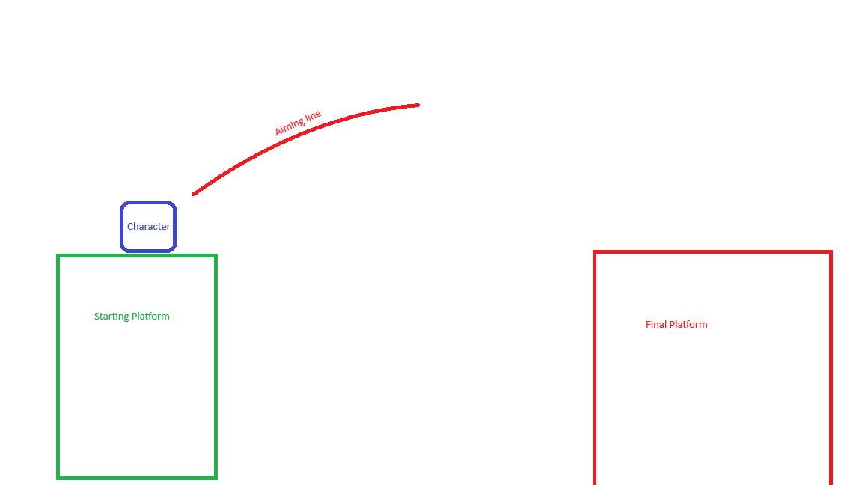
The player will jump from platform to platform whilst battling with the cube’s physics. The player will have limited time indicated by the platform they are on shaking.

Jumping is done by swiping in the direction the player wants to go.
Each time the player jumps the platform the jump will move and get slightly smaller so that the same motion cannot keep jumping the player to the next section. Further the platform the player is on has less time before falling.

Audience
Non-Serious Mobile Game Players that want a game they can briefly pick up and put down. Typically, people between 10 – 20, who have decent reaction time and good mental calculations.

Target Mobile Platform
Android Exclusive on launch, I do not have a Mac to publish with, and I plan to publish this game myself and do not want to also buy a limited time license that I likely won’t use again within its timeframe. Whereas a Play store license is lifetime and I can afford to buy that.

Orientation and Design outline
Landscape, Due to the nature of the game this is required for the game to work. The design will be simple basic shapes and will rely more on the shading and will likely have shadows on a plain backdrop to create a sense of 3 dimensionality. Simplistically designed games often bring in more players than complex ones as they are easier to understand quickly.
Being Landscape means that any camera punch holes will be middle left or right and not likely to get in the way.

Controls:
The Game Will be controlled by the player swiping and holding to draw a line for where they want to go. This will cause the box to jump (with rotation) and then land on the next platform.

UI ON LOAD:
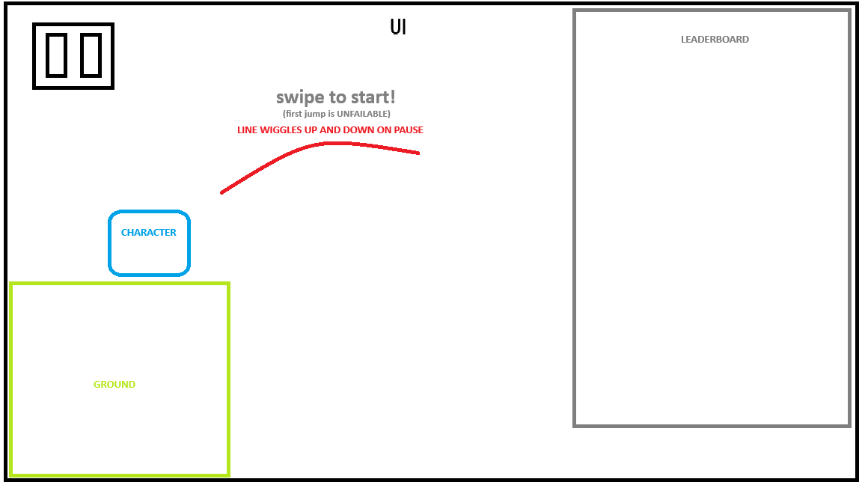
UI ON START:
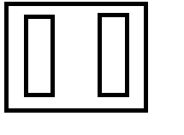
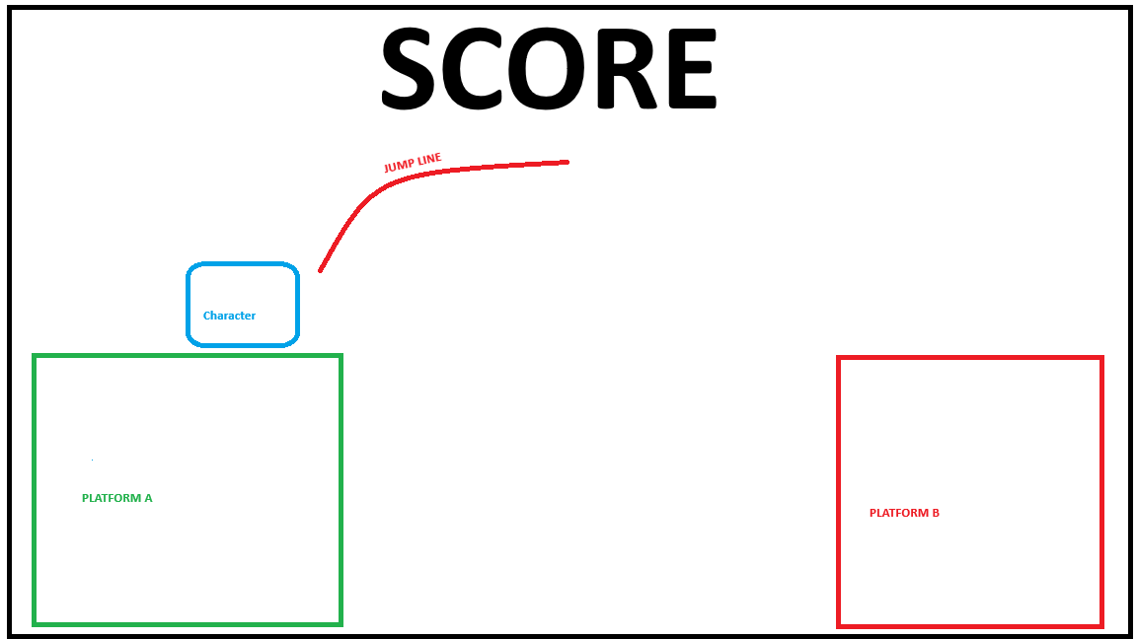
UI ON PAUSE:
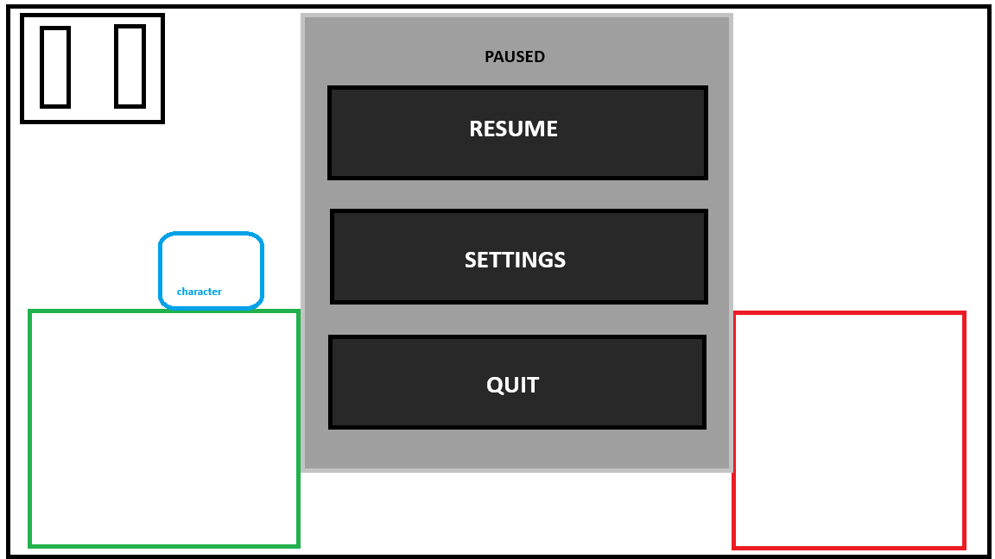

Additional Features That I would like to add
The Features included here are stretch goals and are not part of the main product, they simply exist as extra things I could / want to do given any extra time I may have (they are not within the base scope of the project.
- Local Multiplayer using Local Device connection
- A Vertical Mode Where the player launches upwards for Portrait users
- Colour settings
- Skins
- Ad implementation (even if not included in final release would be nice to know how to do)

